Functional Specification

Year: 2023 Semester: Fall Project Name: Air-Hockey Playing Robot

Creation Date: September 1, 2023 Last Modified: September 2, 2023

Team Members (#1 is Team Leader):

Member 1: Abigale Haluska Email: ahaluska@purdue.edu

Member 2: John Morton Email: morton67@purdue.edu

Member 3: Joey Collins Email: colli384@purdue.edu

Member 4: Cameron McCutcheon Email: mccutchc@purdue.edu

Assignment Evaluation: See Rubric on Brightspace Assignment

1.0 Functional Description

The autonomous air hockey robot is a project dedicated to improving the training experience of air hockey hobbyists and enthusiasts. This project will involve a system composed of a microcontroller, a camera sensor, a PC, two IR proximity sensors, two stepper motors, six pulleys, and 8 7-segment displays. The motors will be attached to cables via a CoreXY system. The cables will also be attached to a paddle, so that the paddle can be moved in the X and Y directions to block and attack a puck.

Two power supplies will be used to power the robot: 1 5-volt power supply and 1 24-volt power supply. A LDO will be used to bring the 5-volt power supply down to 3.3 volts, which will power the PCB, the microcontroller, the IR sensors, and the 7-segment displays. The 24-volt power supply will plug into the wall and power the motor control box and the two stepper motors.

The camera being used in this project is the ELP high-speed wide-angle global shutter USP camera module. This camera shoots 120 frames per second and sends data over USB2.0. The camera will be placed above the air hockey table so that it looks down on the playing field resembling a bird's-eye view. The camera will send image data to the PC over USB2.0.

The PC will leverage a python script and openCV to accept the data sent from the camera as input. The script will use the input frames to identify the puck’s current position along with the trajectory and predicted future location. Data detailing the puck’s future location will be sent to the microcontroller as an 8-bit packet over a USB-to-UART serial adapter.

The USB-to-UART IC being used in this project is the HiLetGo FTDI USB to TTL serial converter module. This component will be used in transferring serial data from the PC to the microcontroller.

The microcontroller being used in this project is the STM32F091RCT6. This microcontroller will determine where the paddle is in relation to the puck using serial data received from the PC. The microcontroller will then control the motor control module so that the motors move the paddle in a defensive position. This will lead the paddle to block or strike the puck.

The IR sensors being used in this project are IR break beam sensors. If a puck is at any point scored, the puck will fall down a custom funnel shoot and in between two IR sensors. The IR sensors will detect the score and transmit the data to the microcontroller.

The 7-segment displays used in this project are second-hand from a pre-existing air hockey table. The microcontroller will control the 7-segment displays using two 74HC595 8-bit shift registers. To ensure appropriate current flow, at least one TLC sink driver along with PN2907A transistors will be used in supporting the functionality of the displays. Four of the 7-segment displays will be used in recording the current score - 2 displays reflect each player’s individual score. The remaining four displays will be used in displaying the remaining time left in the game. Each game will last 5-minutes. To restart the game, the pre-existing on/off switch will be used.

The functionality of the autonomous air hockey robot is visually represented by Figure 1 of the appendix.

2.0 Theory of Operation

Computer vision and the Core XY motion platform are two key components in the design of the air hockey robot. The data coming from the camera will be processed into instructions for the CoreXY system to execute to allow the robot to play air hockey.

Computer vision is a field of artificial intelligence that focuses on getting meaningful information from image data. The main purpose is to try and mimic how the eyes of a human work when it comes to recognizing and tracking objects, detecting patterns, and matching features.[1] The main purpose of the use of computer vision is to detect where the puck and paddles are in an air hockey game. From the data of where the puck is located, the robot will be able to know where it's going and estimate its trajectory. This information can then be turned into instructions for how the motors should move and react to the puck. See Figure 2 of the appendix for a visualization of computer vision being used to detect a hockey puck and paddles.

CoreXY is a theory of operation on cartesian motion. The main idea behind it is to keep the motors stationary and allow for the rest of the system to move much faster.[2] This will be important to the design of the robot that we are building so that it can be very fast and responsive. The less mass being moved around, the less power is used and less force is exerted to move around all the motors.

The equations listed in figure 3 describe how the motion of the central device will move with relation to the motor motion. This lets the two motors stay stationary and place a lot less strain on the system as a whole.

3.0 Expected Usage Case

The autonomous air hockey table will be used by air hockey enthusiasts and hobbyists for leisure and for training. This robot is designed to be used in a spacious and well-lit indoor environment. Due to the nature of the robot’s design, this product is meant to be stationary; this is not a portable device. This product is designed to accommodate varying skill levels of those ages 5 years and older.

The air hockey robot is designed to be used by one player at a time, so that the player can enjoy a game of air hockey without additional human players present. For air hockey enthusiasts and hobbyists, this robot offers the opportunity for personable and comfortable training.

4.0 Design Constraints

Design constraints play an important role in the development of any project. With the air-hockey robot in particular, design constraints involve the packaging of all electronic components, the visual appearance of the table, and the latency of all major electronic components. Because the air-hockey robot will involve a camera being mounted to the top of the table along with human players making the table vulnerable to movement, it is imperative that the camera, power supply, and other components are housed securely to avoid harming them. Below is the list of constraints the team will be working with in the creation of the Air-Hockey Playing Robot. This list describes the constraints listed above in greater detail.

4.1 Computational Constraints

The bulk of the work being done by the Air-Hockey Playing Robot is being offloaded onto a power PC. The power PC will be performing the computer vision algorithms on the video coming in from the camera in real time to update the estimated path of the puck. The camera currently being looked at is the OptiTrack Flex 3, which can capture 100 frames per second with a 10 millisecond latency. According to estimates, the average air hockey player will hit the puck at around 40 miles per hour or 704 inches per second. At 100 frames per second, the puck will be moving approximately 7 inches between images. The computer vision algorithms will have to be optimized enough to be able to predict the path of the puck by comparing track locations between consecutive images. A tentative goal is to have an estimated path before the puck crosses the halfway line. This will give the power pc about 60 milliseconds to send the path to the microcontroller, assuming the length of the table is 7 feet and the puck speed is 40 miles per hour.

Once the microcontroller receives the predicted path information, it will be responsible for communicating with the motor control module to move the paddle to a desired location on that path. The motors need to be activated within 60 milliseconds with the current goal in mind. Time is the major constraint for this project, which creates the need for a microcontroller with a clock speed fast enough to perform the necessary operations.

As far as memory constraints go, there is no need for an abundant amount. There is no desire to store persistent data, aside from score. The team does not plan to keep a history of previous puck paths.

To summarize, the major computational functions for the Air-Hockey Playing Robot are:

* gathering and transferring images between a camera and power PC
* video processing on images using power PC
* puck path prediction
* transfer of path prediction between power PC and microcontroller
* communication to motor control module
* interfacing with goal detection sensor and LCD

4.2 Electronics Constraints

The first major component is the STM32F0 microcontroller that the team will be using. This microcontroller will interface via USB with the power PC and essentially be the main controller of the system. Output pins will lead to the motor controls for each motor and tell them how to operate.

There will be another independent system that keeps track of the score of the game. This will contain an LCD, two infrared sensors, and a microcontroller to keep track of the score. The signal of the infrared sensors will go into digital pins and the microcontroller will use I2C or SPI to send the LCD information. The system will also have a reset button to set both of the score counters to zero when pressed. A lower voltage of 3.3V would be sufficient to power a smaller scale system like this score counter.

There will be a camera that is housed directly above the air hockey table. This will be connected to the power PC via USB and provide all of the images for processing.

The power PC will provide the bulk of the computational power for the robot. It takes in the images data from the camera via ethernet and sends out the commands to the microcontroller via USB. This will integrate parallel processing on a GPU to make the control calculations much faster.

4.3 Thermal/Power Constraints

Max operating temperature stepper motor: 90 C.

Max operating temperature motor power distributor: 60 C.

There are three potential sources of thermal constraints in the system, those being motor power distribution systems, the motors themselves, and the powerPC. The motor power distribution systems (purchased from Amazon) will have integrated heat sinks. Should these heat sinks be inefficient at diffusing heat away from their body, a simple PC fan should be enough to regulate temperature. Likewise, the power PC should have integrated cooling for both the CPU and GPU (note, only applicable if a single board computer w/ GPU peripheral is used, independent PC tower/ laptop will handle its own dissipation). If the motors themselves overheat, thermal dissipation requirements will be placed on the activity of the system to deactivate/ slow motor power consumption in high usage duty cycles. Note, depending on the physical accessibility of the motor chassis, a PC fan may be capable of providing air flow for cooling.

4.4 Mechanical Constraints

Packaging Constraints:

Along with course requirements for packaging, motors and motor control systems must have thermally dissipative packaging (in accordance with thermal constraints) with sufficient safety measures to minimize risk of electric shock at 48 volts. Additionally, motor mounting to the coreXY pulley system must be packaged safely to minimize risk of tangle hazard.

This is assumed to be an indoor table and thus it does not need to be weatherproof/waterproof or dust proof).

**General Mechanical Constraints:**

As this project is assumed to be non-portable in the prototype stage, requirements of size and weight are identical to those of a standard air hockey table. The mechanical motion system, coreXY, shall be completely constrained to one side of the table. This system shall not contact the play surface of the table, nor shall it affect play in any other way than through the contact mallet.

4.5 Economic Constraints

Given the computational goals of the autonomous air hockey robot, the project faces several economic constraints. In order to achieve high-speed movement of the paddle, this project warrants the need for a camera with high frames per second and low latency. Cameras of these specifications that would be considered for this project cost anywhere from $100 - $600. With that said, the team will dedicate a minimum of $100 of the project budget to a camera that supports the project goals. Additionally, the budget of this project must support the purchase of a functioning air-hockey table, which is predicted to cost an additional $100. These two purchases are expected to be the most expensive individual components of the project. It’s predicted to cost around $250 to support the purchase of motors, cables, and mechanical components, while another $200 will be spent on a microcontroller, circuit board, and electrical components. At the end, the team proposes an initial budget of $805 for this project.

The economic constraints of the discussed components leads the team to consider cameras of lower latency as well as used air hockey tables. Additionally, 3D printing and renting components will be considered as an option in mitigating economic constraints.

4.6 Other Constraints

Space and lighting are additional constraints to be considered in the development of this project. Due to the size of a standard air hockey table as well as the need for an overhead camera, a space of at least 7 by 5 feet will be needed to ensure a comfortable and feasible game of air hockey. Additionally, to ensure that the camera sensor can detect the puck in motion, the environment of use must be well lit so that the camera can recognize the color and/or shape of the puck.

5.0 Sources Cited:

[1] “What is computer vision and how does it work with Artificial Intelligence?,” Algotive, https://www.algotive.ai/blog/what-is-computer-vision-and-how-does-it-work-with-artificial-intelligence (accessed Sep. 2, 2023).

[2] “Cartesian Motion Platform,” CoreXY, https://corexy.com/ (accessed Sep. 2, 2023).

**Appendix 1: Functional Block Diagram**

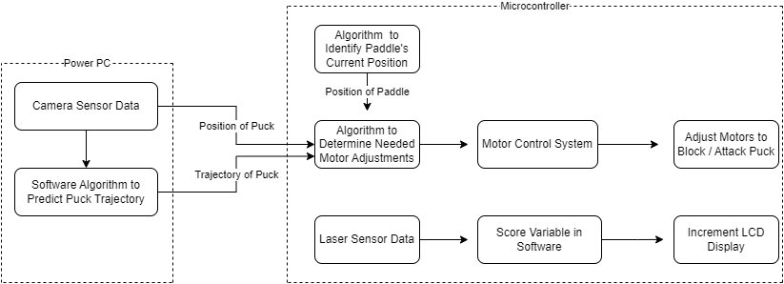

**Appendix 2: OpenCV Detecting Hockey Puck and Paddles**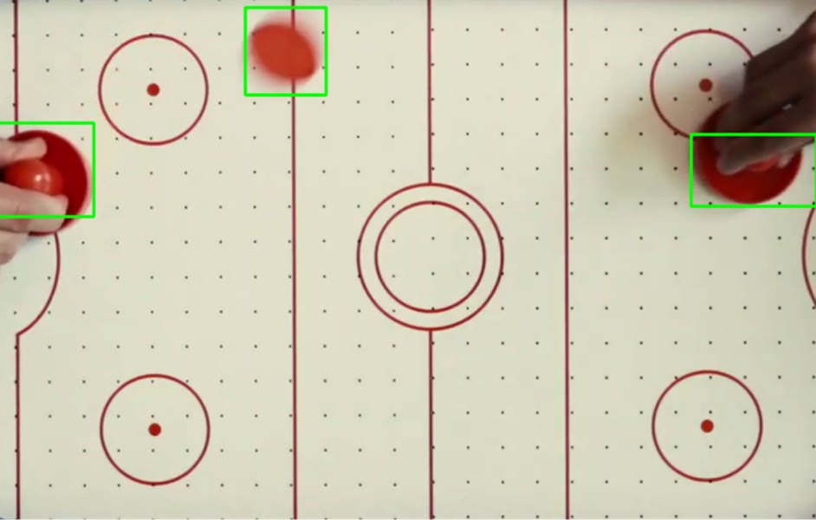

**Appendix 3: An Example of a CoreXY system.**

